Java Problemsheet - 5

Name: Kaaviya S S Roll. no: 22PT15

1. Write a program to create a Room class, the attributes of this class is roomno, roomtype, and
roomarea. Implement the methods calledsetData and displayData to manipulate the data.

import java.util.Scanner;

public class Room {
int roomno;
String roomtype;
float roomarea;

public void setData(int room_num, String room_type, float room_area) {
this.roomno = room_num;
this.roomtype = room_type;
this.roomarea = room_area;
}

public void displayData() {
System.out.printf("\nDisplaying the data: \n");
System.out.println("Room number: " + roomno);
System.out.println("Room type: " + roomtype);
System.out.println("Room area: " + roomarea);
}

public static void main(String[] args) {
Scanner obj = new Scanner(System.in);
System.out.print("Enter the room number: ");
int num = obj.nextInt();
System.out.print("Enter the room type: ");
String type = obj.next();
System.out.print("Enter the room area: ");
float area = obj.nextFloat();

Room r = new Room();
//setting the data
r.setData(num, type, area);
//displaying data
r.displayData();

obj.close();
}
}

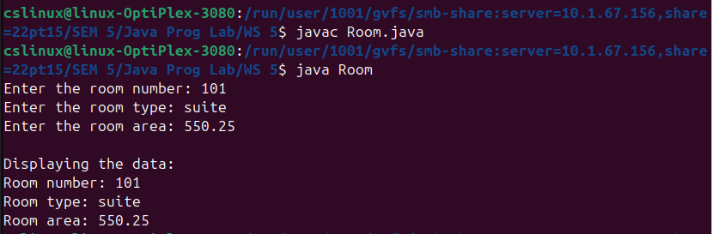

—----------------------------------------------------------------------------------------------------------------------------

2. Create a class Rectangle with attributes length and width, each of which defaults to 1. Provide methods that calculate the rectangle’s perimeter and area. It has set and get methods for both length and width. The set methods should verify that length and width are eachfloating-point numbers larger than 0.0 and less than 20.0. Write a program to test class Rectangle.

import java.util.Scanner;

public class Rectangle {
float length;
float width;

Rectangle() {
length = 1;
width = 1;
}

public float get_length(Scanner scanner) {
System.out.print("Enter the length of rectangle: ");
float l = scanner.nextFloat();
return l;
}

public float get_width(Scanner scanner) {
System.out.print("Enter the width of rectangle: ");
float w = scanner.nextFloat();
return w;
}

public void set(float l, float w) {
if( (l>0.0 && l<20.0) && (w>0.0 && w<20.0) ) {
this.length = l;
this.width = w;
}
}

public float calculate_area() {
return this.length*this.width;
}

public float calculate_perimeter() {
return 2*(this.length + this.width);
}

public static void main(String[] args) {
Scanner scanner = new Scanner(System.in);

Rectangle r = new Rectangle();
float length = r.get_length(scanner);
float width = r.get_width(scanner);
r.set(length, width);

float area = r.calculate_area();
float perimeter = r.calculate_perimeter();

System.out.println("Area of rectangle: " + area);
System.out.println("Perimeter of rectangle: " + perimeter);

scanner.close();
}
}

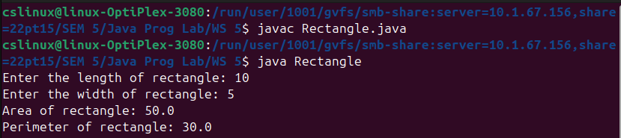

—----------------------------------------------------------------------------------------------------------------------------

3. Create a class named Player with the following private attributes.
String name, int age, String country
Include appropriate getters and setters.
Include a default constructor.
Include a 3-argument constructor. The order in which the parameters are passed is the name,
age, and country. Override the toString method to display the player details.

import java.util.Scanner;

public class Player
{
private String name;
private int age;
private String country;

Player() {
this.name = "";
this.age = 0;
this.country = "";
}

Player(String name, int age, String country)
{
setData(name,age,country);
}

private void setData(String name, int age, String country)
{
this.name = name;
this.age = age;
this.country = country;
}

public String getName() {
return this.name;
}

public int getAge() {
return this.age;
}

public String getCountry() {
return this.country;
}

@Override public String toString() {
return "\nPlayer's details: \nName: " + this.name + "\nAge: " + this.age + "\nCountry: " + this.country;
}

public static void main(String args[])
{
Scanner obj = new Scanner(System.in);

System.out.print("Enter the player name: ");
String name = obj.next();
System.out.print("Enter the player age: ");
int age = obj.nextInt();
System.out.print("Enter the player's Country: ");
String country = obj.next();

Player player = new Player(name, age, country);

System.out.println(player.toString());

obj.close();
}
}

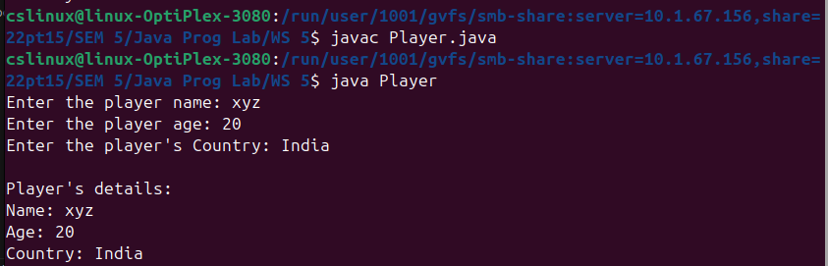

—----------------------------------------------------------------------------------------------------------------------------

4. Create a class called Complex for performing arithmetic with complex numbers. Complex
numbers have the form
realPart + imaginaryPart * i, where i is√−1
Write a program to test your class. Use floating-point variables to represent the private data
of theclass. Provide a constructor that enables an object of this class to be initialized when
it’s declared.Provide a no-argument constructor with default values in case no initializers are
provided. Providepublic methods that perform the following operations:
a) Add two Complex numbers: The real parts are added together and the imaginary partsare
added together.
b) Subtract two Complex numbers: The real part of the right operand is subtracted fromthe
real part of the left operand, and the imaginary part of the right operand is subtractedfrom the
imaginary part of the left operand.
c) Print Complex numbers in the form (realPart, imaginaryPart).

import java.util.Scanner;

public class Complex {
private double real, imaginary;

Complex()
{
this.real = 0.0;
this.imaginary = 0.0;
}

Complex(double real, double imaginary)
{
this.real = real;
this.imaginary = imaginary;
}

public void addition(Complex num1, Complex num2)
{
this.real = num1.real + num2.real;
this.imaginary = num1.imaginary + num2.imaginary;
}

public void subtraction(Complex num1, Complex num2)
{
this.real = num1.real - num2.real;
this.imaginary = num1.imaginary - num2.imaginary;
}

public void display()
{
System.out.println("( " + this.real + " , " + this.imaginary + " )");
}

public static void main(String args[])
{
Scanner obj = new Scanner(System.in);

System.out.print("Enter the real part of 1st complex number: ");
double r1 = obj.nextDouble();
System.out.print("Enter the imaginary part of 1st complex number: ");
double i1 = obj.nextDouble();

System.out.print("Enter the real part of 2nd complex number: ");
double r2 = obj.nextDouble();
System.out.print("Enter the imaginary part of 2nd complex number: ");
double i2 = obj.nextDouble();

Complex num1 = new Complex(r1, i1);
Complex num2 = new Complex(r2, i2);

System.out.printf("\ncomplex number 1: " );
num1.display();
System.out.printf("complex number 2: " );
num2.display();

Complex addResult = new Complex();
addResult.addition(num1,num2);
System.out.printf("Addition result: ");
addResult.display();

Complex subtractResult = new Complex();
subtractResult.subtraction(num1,num2);
System.out.printf("Subtraction result: ");
subtractResult.display();

obj.close();
}
}

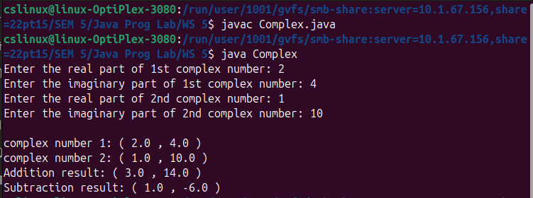

—----------------------------------------------------------------------------------------------------------------------------

5. Create a class named BloodData that includes fields that hold a blood type (the four blood types are O, A, B, and AB) and an Rh factor (the factors are + and –). Create a default constructor that sets the fields to O and +, and an overloaded constructor that requires values for both fields. Include get and set methods for each field. Create a class named Patient that includes an ID number, age, and BloodData. Provide a default constructor that sets the ID number to 0, the age to 0, and the BloodData values to O and +. Create an overloaded constructor that provides values for each field. Also provide get methods for each field. Create an application that demonstrates thateach method works correctly and test it.

import java.util.Scanner;

class BloodType
{
public String bloodType;
public char Rh;

public BloodType()
{
this.bloodType = "O";
this.Rh = '+';
}

public BloodType(String blood_type, char rh)
{
setData(blood_type,rh);
}

private void setData(String blood_type, char rh)
{
blood_type = blood_type.toUpperCase();
if( blood_type.equals("A") || blood_type.equals("B") || blood_type.equals("AB") || blood_type.equals("O") )
this.bloodType = blood_type;
else {
System.out.println("Invalid Blood type is entered! Setting blood type to 'O' by default");
this.bloodType = "O";
}

if( rh == '+' || rh == '-' )
this.Rh = rh;
else {
System.out.println("Invalid Rh Factor! Setting Rh Factor to '+' by default");
this.Rh = '+';
}
}

public String getBloodType() {
return bloodType;
}

public char getRh() {
return Rh;
}
}

class Patient
{
public String ID;
public int age;
public BloodType blood;

public Patient()
{
this.ID = "0";
this.age = 0;
this.blood = new BloodType();
}

public Patient(String ID, int age, String blood_type, char rh)
{
this.ID = ID;
if(age >= 0)
this.age = age;
else
System.out.println("Invalid Age is entered! setting to 0 by defalut");
this.blood = new BloodType(blood_type, rh);
}

public String getID() {
return ID;
}

public int getAge() {
return age;
}

public BloodType getBlood() {
return blood;
}

}

public class PatientBloodData
{
public static void main(String[] args) {
Scanner obj = new Scanner(System.in);

Patient p1 = new Patient();
System.out.println("Default Patient details: ");
System.out.println("ID: " + p1.getID());
System.out.println("Age: " + p1.getAge());
System.out.println("Blood Type: " + p1.getBlood().getBloodType() + p1.getBlood().getRh());

System.out.printf("\nFor new patient, enter the details: \n");
System.out.print("Enter patient ID: ");
String id = obj.nextLine();
System.out.print("Enter patient Age: ");
int age = obj.nextInt();
System.out.print("Enter patient Bloodtype: ");
String blood_type = obj.next();
System.out.print("Enter patient Rh Factor(+ or -): ");
char rh = obj.next().charAt(0);
Patient p2 = new Patient(id,age,blood_type,rh);

System.out.printf("\nEntered Patient details: \n");
System.out.println("ID: " + p2.getID());
System.out.println("Age: " + p2.getAge());
System.out.println("Blood Type: " + p2.getBlood().getBloodType() + p2.getBlood().getRh());

obj.close();
}
}

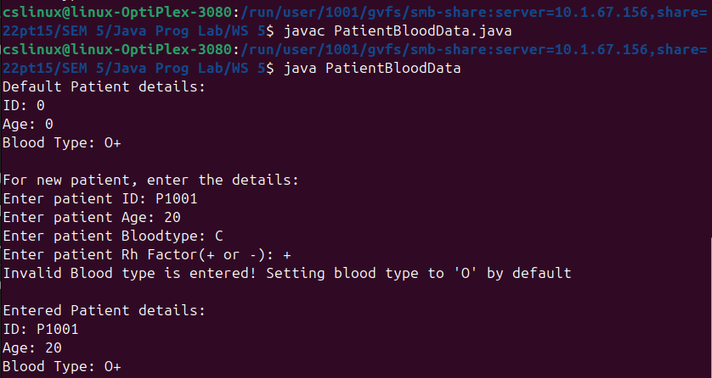

—----------------------------------------------------------------------------------------------------------------------------

6. Design a Stack class with the following methods as shown in the below UML class diagram.

import java.util.Scanner;

public class StackOfIntegers {
private int size;
private int[] elements;

StackOfIntegers() {
this.size = 0;
this.elements = new int[10];
}

StackOfIntegers(int n) {
this.size = 0;
this.elements = new int[n];
}

public boolean empty() {
return size==0;
}

public int peek() {
if(empty())
return -1;
else
return elements[size];
}

public void push(int value) {
if(size==elements.length) {
System.out.println("Maximum size of the stack is reached!");
}
else {
this.elements[++size] = value;
System.out.println("Inserted: " + value);
}
}

public int pop() {
if(empty()) {
System.out.println("Stack is empty!");
return -1;
}
return this.elements[size--];
}

public int getSize() {
return this.size;
}

public static void main(String[] args) {

Scanner obj = new Scanner(System.in);

System.out.print("Enter no. of elements in stack: ");
int n = obj.nextInt();

StackOfIntegers stack = new StackOfIntegers(n);

System.out.println("Stack operations: ");
System.out.println("1. Push");
System.out.println("2. Pop");
System.out.println("3. Peek");
System.out.println("4. Check if empty");
System.out.println("5. Get size");
System.out.println("6. Exit");

while (true) {
System.out.print("Enter your choice: ");
int ch = obj.nextInt();

if(ch==1) {
System.out.print("Enter element to push: ");
int value = obj.nextInt();
stack.push(value);
System.out.println("");
}

else if(ch==2) {
System.out.println("popped element: " + stack.pop());
System.out.println("");
}

else if(ch==3) {
System.out.println("Top element: " + stack.peek());
System.out.println("");
}

else if(ch==4) {
System.out.println("Is empty: " + stack.empty());
System.out.println("");
}

else if(ch==5) {
System.out.println("Size: " + stack.getSize());
System.out.println("");
}

else
break;
}

obj.close();
}
}

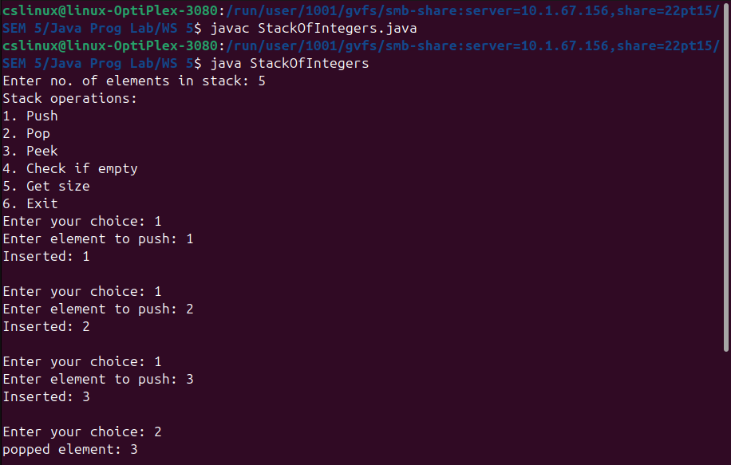
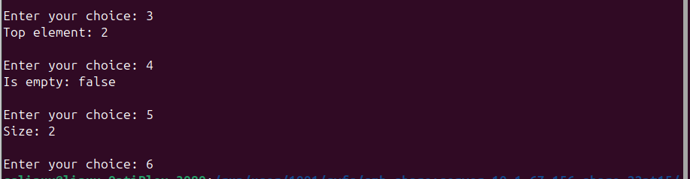

—----------------------------------------------------------------------------------------------------------------------------

7. A class called Customer, which models a customer in a transaction, is designed as shown in the class diagram. A class called Invoice, which models an invoice for a particular customer and composes an instance of Customer as its instance variable, is also shown. Design the Customer and Invoice classes with following methods as shown in the below UML class diagram. Also develop test driver class have main( ) method to test the below model.

import java.util.Scanner;

class Customer
{
public int id;
public String name;
public int discount;

public Customer(int id, String name, int discount)
{
this.id = id;
this.name = name;
this.discount = discount;
}

public int getID() {
return this.id;
}

public String getName() {
return this.name;
}

public int getDiscount() {
return this.discount;
}

public void setDiscount(int d) {
this.discount = d;
}

@Override public String toString() {
return this.name + "(" + this.id + ")(" + this.discount + "%)";
}
}

class Invoice
{
public int id;
public Customer customer;
public double amount;

public Invoice(int id, Customer c, double amount)
{
this.id = id;
this.customer = c;
this.amount = amount;
}

public int getID() {
return this.id;
}

public Customer getCustomer() {
return this.customer;
}

public void setCustomer(Customer c) {
this.customer = c;
}

public double getAmount() {
return this.amount;
}

public void setAmount(double a) {
this.amount = a;
}

public int getCustomerID() {
return this.customer.getID();
}

public String getCustomerName() {
return this.customer.getName();
}

public int getCustomerDiscount() {
return this.customer.getDiscount();
}

public double getAmountAfterDiscount() {
double amt = (amount*this.getCustomerDiscount())/100;
return (this.amount - amt);
}

@Override public String toString() {
return "Invoice[" + "id=" + this.id + ", customer=" + this.customer + ", amount=" + this.amount + "]";
}
}

public class CustomerInvoice
{
public static void main(String args[]) {

Scanner obj = new Scanner(System.in);

System.out.print("Enter the customer id: ");
int id = obj.nextInt();
System.out.print("Enter customer's name: ");
String name = obj.next();
System.out.print("Enter Discount percent: ");
int discount = obj.nextInt();
System.out.print("Enter total amount: ");
int amount = obj.nextInt();

Customer C = new Customer(id,name,discount);
Invoice I = new Invoice(1, C, amount);

System.out.print("\n\nCustomer and Invoice Details: \n");
System.out.println("Customer : " + C.toString());
System.out.println("Invoice : " + I.toString());
System.out.println("Customer ID : " + I.getCustomerID());
System.out.println("Customer name : " + I.getCustomerName());
System.out.println("Total amount: " + I.getAmount());
System.out.println("Discount(%) : " + I.getCustomerDiscount());
System.out.println("After Discount : " + I.getAmountAfterDiscount());

obj.close();
}
}

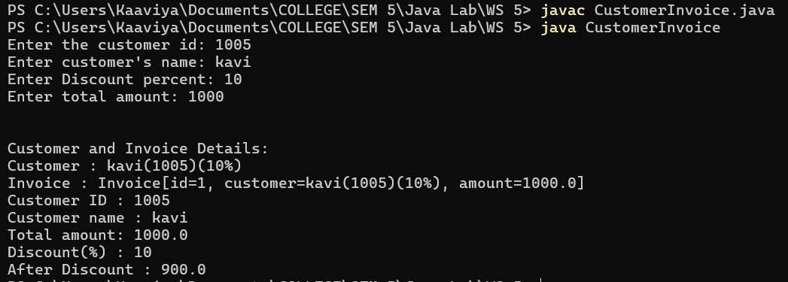

—----------------------------------------------------------------------------------------------------------------------------

8. Create a simplified e-commerce payment gateway using interfaces. Design an interface named PaymentProcessor with methods for processing payments, validating credit cards, and generating receipts. Implement this interface in classes representing different payment methods (e.g., CreditCard, PayPal). Develop a program that simulates the payment process for online purchases.

import java.util.Scanner;

interface PaymentProcessor
{
void processPayment(double amount);
boolean validatePaymentMethod();
String generateBill(double amount);
}

class PayPal implements PaymentProcessor
{
String UPI_id;
String password;

public PayPal(String id, String pwd)
{
this.UPI_id = id;
this.password = pwd;
}

@Override public void processPayment(double amount)
{
System.out.println("Processing PayPal amount : Rs." + amount + "\n");
}

@Override public boolean validatePaymentMethod()
{
System.out.print("--Validating PayPal Payment Method--\n");
if(this.UPI_id.contains("@") && this.password.length()>=6)
return true;
else
return false;
}

@Override public String generateBill(double amount)
{
return "\n*** PayPal Receipt of Rs." + amount + " is paid using the account " + this.UPI_id + " ***\n";
}
}

class CreditCard implements PaymentProcessor
{
String cardNo;
String expiryData;
String cvv;

public CreditCard(String cardNo, String expiryData, String cvv)
{
this.cardNo = cardNo;
this.expiryData = expiryData;
this.cvv = cvv;
}

@Override public void processPayment(double amount)
{
System.out.printf("\nProcessing Credit card amount : Rs." + amount + "\n");
}

@Override public boolean validatePaymentMethod()
{
System.out.printf("\n\n--Validating Credit card Payment Method--\n");

boolean isdigit = true;
for(int i=0; i<this.cardNo.length(); i++) {
if(!Character.isDigit(this.cardNo.charAt(i))) {
isdigit = false;
break;
}
}
if( this.cardNo.length()==16 && isdigit && (cvv.length()==3 || cvv.length()==4) )
return true;
else
return false;
}

@Override public String generateBill(double amount)
{
return "\n*** Credit card Receipt of Rs." + amount + " is paid using the card number " + this.cardNo + " ***\n";
}
}

public class PaymentGateway
{
public static void main(String[] args)
{
Scanner obj = new Scanner(System.in);

System.out.print("Enter the amount to be paid: Rs.");
double amount = obj.nextDouble();

System.out.printf("\nEnter the mode of payment: \n1. PayPal \n2. Credit card \n");
System.out.print("Enter your choice: ");
int ch = obj.nextInt();

if(ch==1)
{
System.out.print("\nEnter the UPI ID: ");
String upi = obj.next();
System.out.print("Enter the password: ");
String pwd = obj.next();

PayPal paypal = new PayPal(upi,pwd);
paypal.processPayment(amount);
if(paypal.validatePaymentMethod()) {
System.out.println("Payment is valid!");
System.out.println(paypal.generateBill(amount));
}
else {
System.out.println("\nPayment is invalid!");
}
}
else if(ch==2)
{
System.out.print("\nEnter the 16-digit credit card number: ");
String card_no = obj.next();
System.out.print("Enter the Expiry Date(MM/YYYY): ");
String date = obj.next();
System.out.print("Enter the CVV number (3 or 4 digit): ");
String cvv = obj.next();

CreditCard credit_card = new CreditCard(card_no, date, cvv);
credit_card.processPayment(amount);
if(credit_card.validatePaymentMethod()) {
System.out.println("Payment is valid!");
System.out.println(credit_card.generateBill(amount));
}
else {
System.out.println("Payment is invalid!");
}
}
else
{
System.out.println("Invalid payment method!");
}

obj.close();
}
}

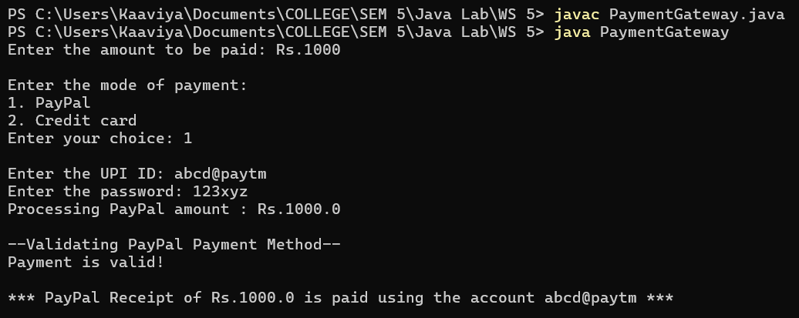
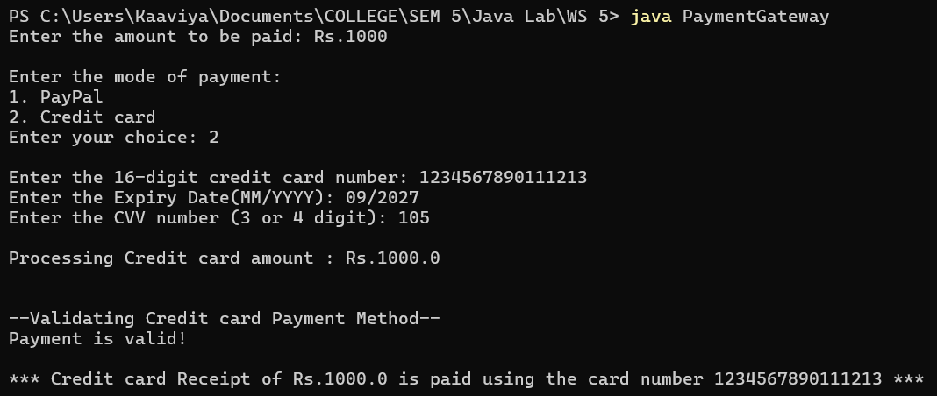

—----------------------------------------------------------------------------------------------------------------------------

9. Create an abstract class named Element that holds properties of elements, including their symbol, atomic number, and atomic weight. Include a constructor that requires values for all three properties and a get method for each value. (For example, the symbol for carbon is C, its atomic number is 6, and its atomic weight is 12.01. You can find these values by reading a periodic table in a chemistry reference or by searching the Internet.) Also include an abstract method named describeElement(). Create two extended classes named MetalElement and NonMetalElement. Each contains a describeElement( ) method that displays the details of the element and a brief explanation of the properties of the element type. For example, metals are good conductors of electricity, while nonmetals are poor conductors. Write an application named ElementArray that creates and displays an array that holds at least two elements of each type.

import java.util.Scanner;

abstract class Element
{
String symbol;
int atomicNumber;
double atomicWeight;

public Element(String symbol, int number, double weight)
{
this.symbol = symbol;
this.atomicNumber = number;
this.atomicWeight = weight;
}

public String getSymbol() {
return this.symbol;
}

public int getAtomicNumber() {
return this.atomicNumber;
}

public double getAtomicWeight() {
return this.atomicWeight;
}

public abstract void describeElement();
}

class MetalElement extends Element
{
public MetalElement(String symbol, int atomicNumber, double atomicWeight)
{
super(symbol, atomicNumber, atomicWeight); //reference to the parent class variables
}

@Override public void describeElement()
{
System.out.println("\nMetal Element: " + this.getSymbol());
System.out.println("Atomic Number: " + this.getAtomicNumber());
System.out.println("Atomic Weight: " + this.getAtomicWeight());
System.out.println("Metals are good conductors of electricity and heat.\n");
}
}

class NonMetalElement extends Element
{
public NonMetalElement(String symbol, int atomicNumber, double atomicWeight)
{
super(symbol, atomicNumber, atomicWeight); //reference to the parent class variables
}

@Override public void describeElement()
{
System.out.println("\nNon-Metal Element: " + this.getSymbol());
System.out.println("Atomic Number: " + this.getAtomicNumber());
System.out.println("Atomic Weight: " + this.getAtomicWeight());
System.out.println("Non-Metals are poor conductors of electricity and heat.\n");
}
}

public class ElementArray
{
public static void main(String[] args)
{
Scanner obj = new Scanner(System.in);

System.out.print("Enter no. of elements in arr: ");
int n = obj.nextInt();

Element element[] = new Element[n];

String symbol;
int number;
double weight;

for(int i=0; i<n; i++)
{
System.out.println("Element " + (i+1) + ":");
System.out.print("Enter symbol: ");
symbol = obj.next();
System.out.print("Enter Atomic Number: ");
number = obj.nextInt();
System.out.print("Enter Atomic Weight: ");
weight = obj.nextDouble();

System.out.println("Enter the type of element: \n1.Metal \n2.Non Metal");
System.out.print("Enter your choice: ");
int ch = obj.nextInt();

if(ch==1)
{
element[i] = new MetalElement(symbol, number, weight);
element[i].describeElement();
}
else
{
element[i] = new NonMetalElement(symbol, number, weight);
element[i].describeElement();
}
}

obj.close();

}
}

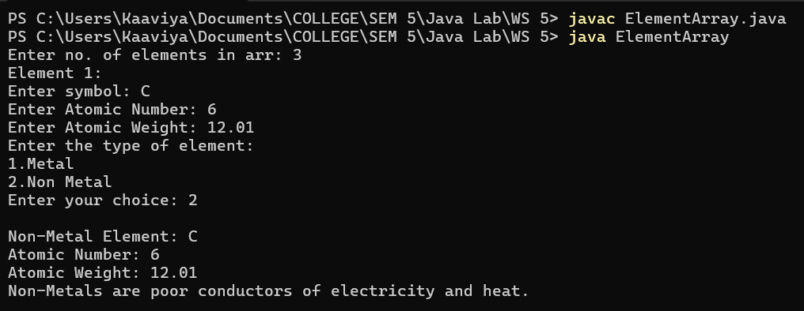
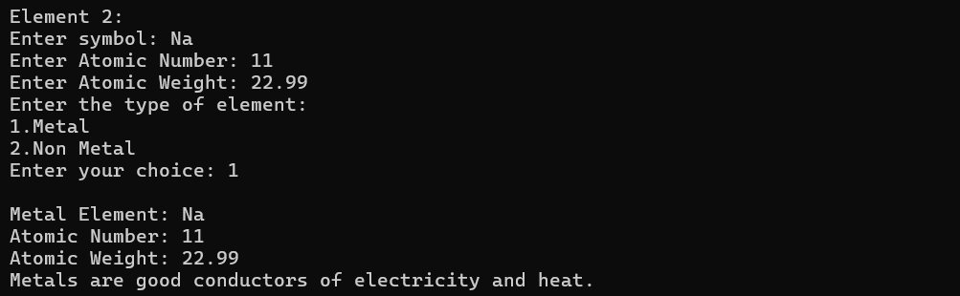
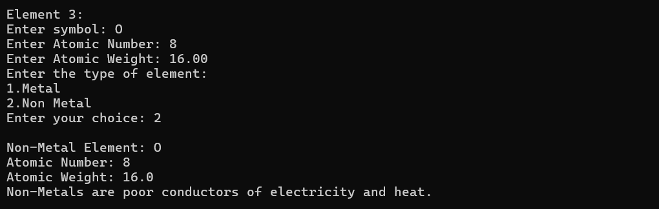

—----------------------------------------------------------------------------------------------------------------------------

10. Create a package called General.
a. Create a one class in it called Person with appropriate properties and methods.
Create 2nd package called StudentDetail.
a. Create a class called Student which derives from Person class with appropriate properties and method.
b. Create a class called Exam with its additional properties and methods which is derived
from Student class.
Create 3rd package called FacultyDetail.
Create a class called Faculty which derives from Person class with appropriate properties and method.
Create 4th package called Test. Make a driver class to test Exam and Faculty class by
creating the objects of them.

//Person.java
package General;

public class Person
{
public String name;
public int age;
public String address;

public Person(String name, int age, String address)
{
this.name = name;
this.age = age;
this.address = address;
}

public String getName() {
return this.name;
}

public int getAge() {
return this.age;
}

public String getAddress() {
return this.address;
}

@Override public String toString() {
return "\nPerson Details: \n" +
"Name: " + this.name + "\n" +
"Age: " + this.age + "\n" +
"Address: " + this.address + "\n";
}
}

//Student.java
package StudentDetail;

import General.Person;

public class Student extends Person
{
public String studentID;
public String major;

public Student(String name, int age, String address, String id, String major)
{
super(name, age, address);
this.studentID = id;
this.major = major;
}

public String getStudentID() {
return this.studentID;
}

public String getMajor() {
return this.major;
}

@Override public String toString() {
return "Student Details: \n" +
"Student ID: " + this.studentID + "\n" +
"Major: " + this.major + "\n" +
super.toString() + "\n";
}
}

//Exam.java
package StudentDetail;

import java.util.Date;

public class Exam extends Student
{
public Date examDate;
public String grade;

public Exam(String name, int age, String address, String id, String major, Date date, String grade)
{
super(name, age, address, id, major);
this.examDate = date;
this.grade = grade;
}

public Date getDate() {
return this.examDate;
}

public String getGrade() {
return this.grade;
}

@Override public String toString() {
return "\nExam Details: \n" +
"Exam Date: " + this.examDate + "\n" +
"Grade: " + this.grade + "\n" +
super.toString() + "\n";
}
}

//Faculty.java
package FacultyDetail;

import General.Person;

public class Faculty extends Person
{
public String FacultyId;
public String department;

public Faculty(String name, int age, String address, String id, String department)
{
super(name, age, address);
this.FacultyId = id;
this.department = department;
}

public String getFacultyId() {
return this.FacultyId;
}

public String getDepartment() {
return this.department;
}

@Override public String toString() {
return "\nFaculty Details: \n" +
"Faculty ID: " + this.FacultyId + "\n" +
"Department: " + this.department + "\n" +
super.toString() + "\n";
}
}

//TestDriverPackage.java
package Test;

import FacultyDetail.Faculty;
import StudentDetail.Exam;

import java.util.Date;

public class TestDriverPackage
{
public static void main(String args[])
{
System.out.println("Creating Exam Object...");
Exam exam = new Exam("abc", 20, "123 Main St", "S12345", "Theoretical Computer Science", new Date(), "A");
System.out.println(exam.toString());

System.out.println("Creating Faculty Object...");
Faculty faculty = new Faculty("abc", 32, "123 Park St", "F123", "Mathematics");
System.out.println(faculty.toString());

}
}





